**Observative trends base on the given data:**

**School District vs School Charter**

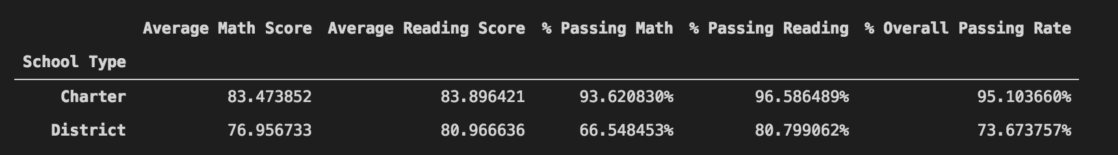

We can easily observe that school charter have more potential of keeping their average students with high passing rate using less budget than School District. This may be due to high the high quality instructors and students scholarships.

**Low Spending Ranges vs High Spending Ranges**

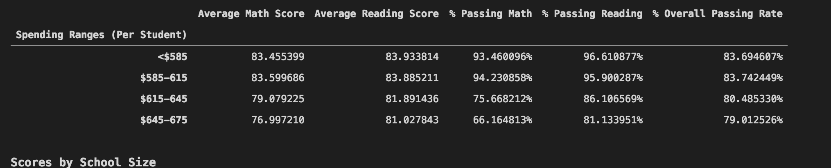

For some reason low spending per student have higher score an passing rate than those students that are spending more. I can’t provide a more detail summary with this given row data to determine what may be the reason(s) why this trend is like this.